**LAB # 02**

**Task # 1: Configuring Android Device to run application.**

* + - **Android Virtual Device.**
      * **Creating, Starting, Stopping, Docking etc.**
    - **Using ADB**
      * **Enabling developer options.**
      * **Enabling USB debugging within developer options.**
      * **Listing attached devices from command prompt.**
      * **USB debugging authorizations on device.**
      * **Attaching device within network.**

**Solution:**

**Android Virtual Device.**

**Creating new Device:**

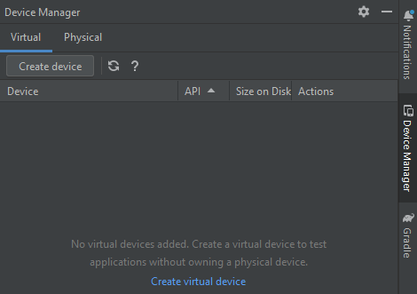

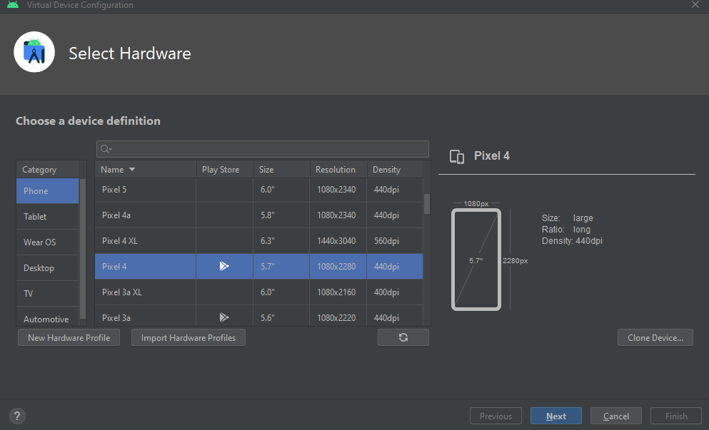

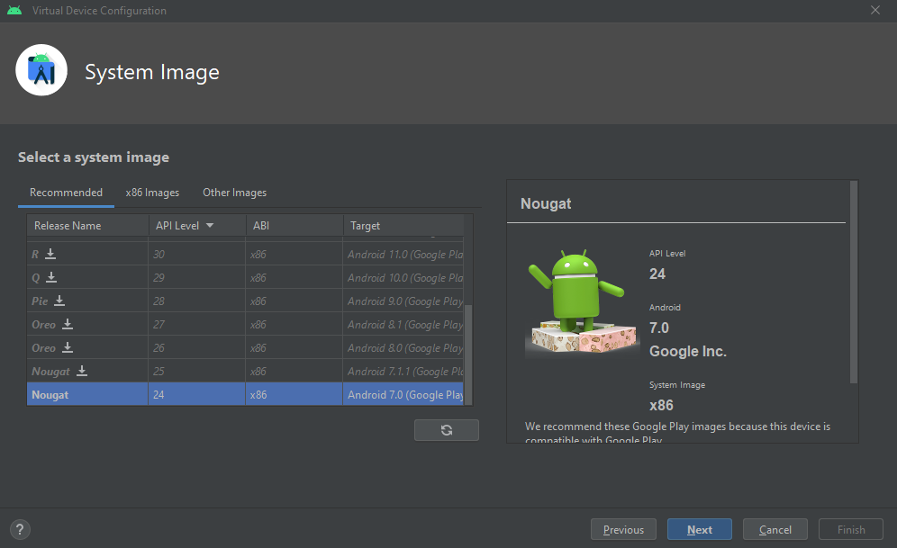

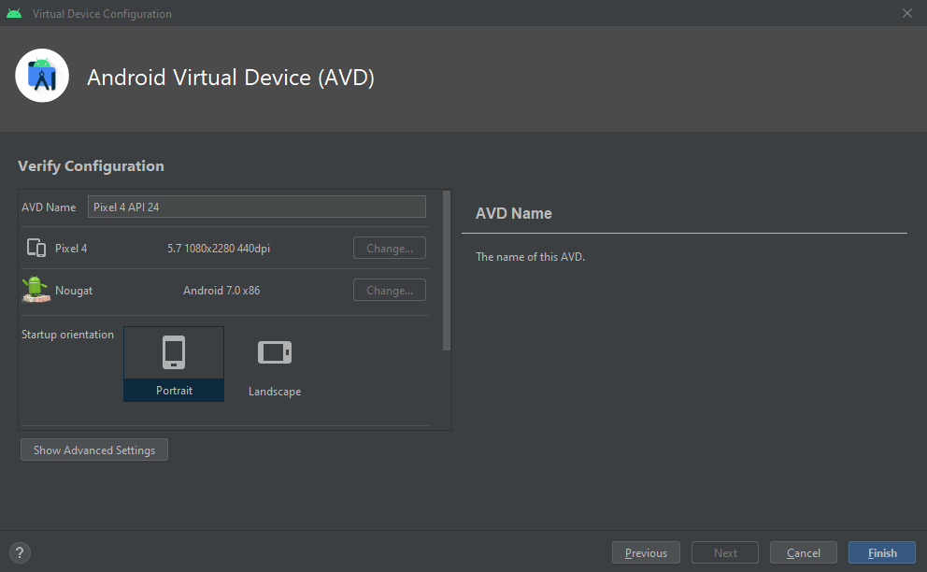

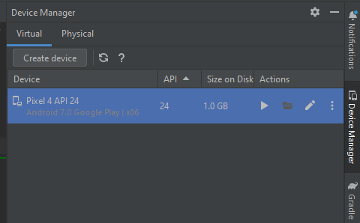

**Starting New Device:** 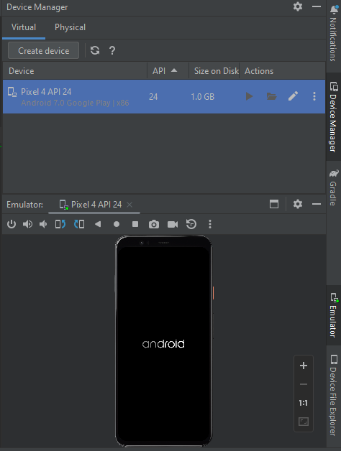

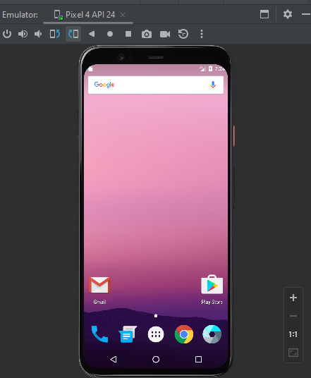

**Stopping Device:** 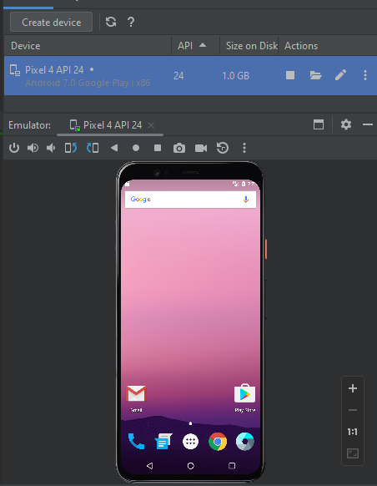

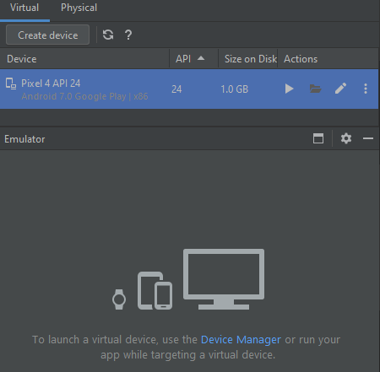

**Configuration Using ADB:**

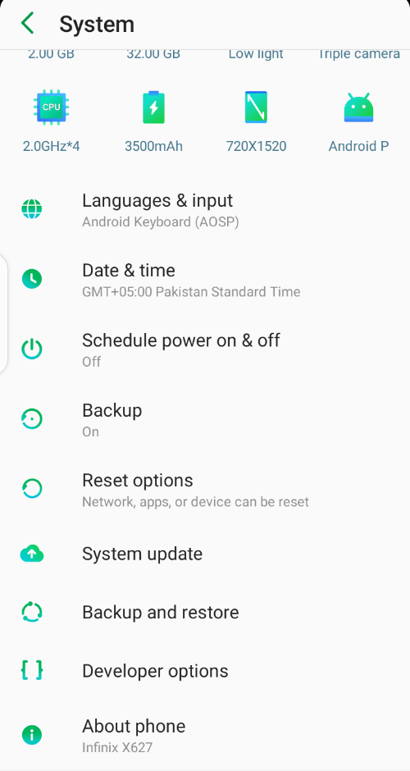 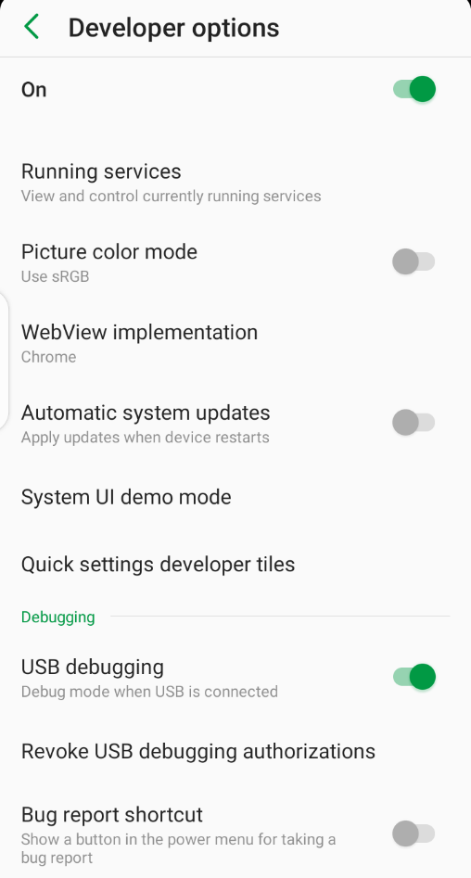

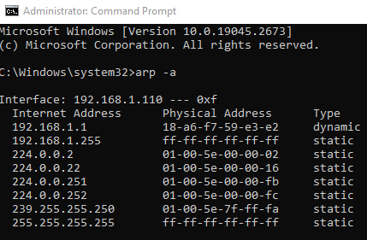 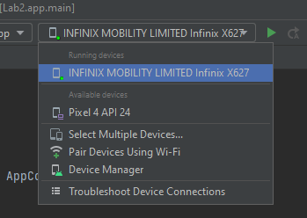

**Task # 2: Running a template-based application on device.**

**On Virtual Device:**

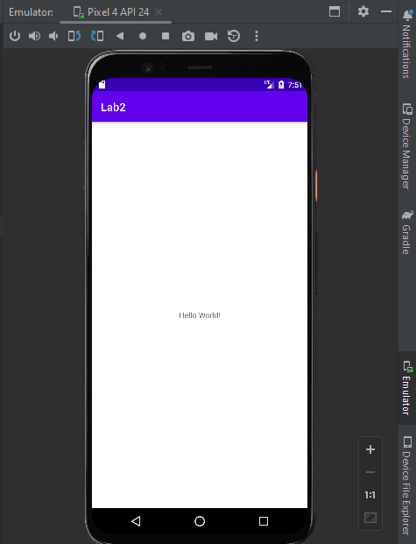

**On Attached Device:** 